**A review of innovative materials for the design of adaptive biomimetic façades**

**Evelyn Grillo1*, Martino Milardi1, Francesca Olivieri2**

*1 Department of Architecture and Territory, Mediterranea University of Reggio Calabria, Italy*

*2 Department of Construction and Technology in Architecture, Universidad Politécnica de Madrid, Spain*

**Abstract**

For several years now, the debate on climate change has become increasingly central because of the consequences of climate anomalies for different sectors of human activity and the built environment. According to the latest Working Group 1 Intergovernmental Report on Climate Change (IPCC), the level of global warming can exceed 1.5°C in the coming decades. With the increase in the average temperature in the Mediterranean area, there will probably be an aggravation in the incidence of heatwaves and intense rainfall with significant repercussions in environmental, social, and economic terms. Therefore, solutions are needed to cope with these problems, and research lines are increasingly focused on the development of adaptive building envelopes to curbing the adverse consequences of climate change. The study refers to ongoing experimental research that aims to define an adaptive component, for continuous facade systems, using innovative materials based on the biomimetic approach. In this paper, the authors present some parts of their research results, where a necessary step was a systematic review of adaptive façade systems, whose variability is related to the intrinsic properties of the material they are made of. Assuming nature as a model, the authors study molecular-scale or nanomaterial materials that change their configuration and adapt to an external stimulus, organically and passively, without the requirement of sophisticated energy systems. For example, materials regulate their adaptive behavior through modifications that alter their interior structure, such as a temperature difference, or by exchanging energy from one form to another. Incorporating these biomimetic principles in the definition of the component can contribute to the design of sustainable architectural systems to “tune” the façade to changing external climatic conditions.

*Keywords:* Climate change; Biomimetic approach; Temperature control; Adaptive façades; Innovative materials

1. **Introduction**

Currently, climate change is the biggest problematic issue internationally, harming the built environment, economy, health, and development of Countries. Hence the relevance and urgency of reaching Sustainable Development Goal (SDG) 13, Climate Action, promoted by the United Nations (UN), which aims to make the implementation of climate change measures into national policies (ONU, 2015). Confirming this scenario, the first part of the Sixth Assessment Report (AR6) of Working Group 1 of the *Intergovernmental Panel on Climate Change* (IPCC) notes that global warming will reach or exceed 1.5°C around 2040 (IPCC, 2021). In the period from 2006 and 2015, the temperature increased by 0.87 °C with regard to the period 1850-1900. Therefore, to reduce global warming, Cities, Regions, States, and Companies have to go through several complex and connected transformations to reduce greenhouse gas emissions. But, where do the emissions come from? Website *Our World in Data* has published the latest breakdown of total greenhouse gas emissions in 2016. Based on data compiled by *Climate Watch* and the *World Resources Institute*, one-fifth of emissions come from agriculture and land use, and the remaining 8% from the waste industry. The largest share of emissions is related to energy, 73.2% of the total (three-quarters of emissions), which also includes energy uses in buildings (17.5% of the total, broken down into residential buildings 10.9% and commercial buildings 6.6%) (Tsai et al., 2022), industries (24.2%) and transport (16.2%), besides other causes such as emissions that 'leak' in the energy production phase (5.8%) (Ritchie, 2020). This scenario shows how the construction sector is directly involved in environmental and energy dynamics. The construction sector is called upon to develop new processes, application methods, and innovative technological solutions that can raise the quality levels of the built environment and contribute significantly to the climate objectives of European policies. Because of this, it is well known how radically building envelopes have changed the way the various players in the industry approach building design, becoming a pivotal element of construction that defines performance quality but regulates internal conditions independently of transient external ones.

Specifically, the climatic conditions in the Mediterranean Area will be characterized by a rise in temperature leading to more intense islands and heat waves, extreme rainfall phenomena such as water bombs and floods, and increasingly frequent micro-typhoons known as 'Medcane', cyclones formed in the Mediterranean (Gaertner et al., 2018). According to the *Mediterranean Experts on Climate and Environmental Change* (MedECC), the increase in warm temperature extremes will be critical, especially in the summer season, and cold days will decrease (MedECC, 2020).

These extreme events reverberate on buildings and become a critical point, especially for external façades. However, the evolution of construction processes and the use of advanced technologies to raise the performance qualities of buildings have enabled the realization of building envelopes that interact with the external environment and conform by taking into account material and immaterial flows. It follows from the above that the new adaptive functioning of the envelope (Attia et al., 2020; Romano et al., 2018) is relevant in the responses to stress phenomena to limit impacts and stressful conditions on the built environment. In particular, adaptive façades are multifunctional systems that can vary their characteristics and behavior to improve the overall performance of the building envelope (Loonen et al., 2015).

Ongoing experimental research investigates the use of innovative materials based on the biomimetic approach, intending to define an adaptive component. The adaptive component can be applied to curtain wall systems, which are exposed to thermal stresses and the incidence of precipitation, causing cracks and fissures in materials, sealants, and gaskets (Burton, 2012). The advances produced by new technologies mark the way for a new relationship between design and biology through today's remarkable technical capabilities to interpret and emulate nature. This multi-disciplinary approach (inherent in the adaptive requirement of building envelopes), known as ‘Biomimicry’ (Benyus, 2002), is inspired by the forms found in nature and the mechanisms that govern it to apply them to design solutions and experiments, contributing to an increase in the performance required of buildings today. Therefore, Biomimicry is not an alternative approach to the classical one but rather an integrative one, considering aspects of wellbeing, healthiness, and sustainability from an ecological perspective.

In this article, the authors describe some of the research results achieved so far. The systematic review is based on those materials that regulate their adaptive behavior to a change in temperature, one of the extreme events in the Mediterranean Area. In particular, the article deals with the materials used to adapt the building envelope to the surrounding environment by the cutting-edge technology of recent years. A short illustration on the biomimicry is introduced, highlighting the main features, methods, and emulative-design approaches. Case studies of experimental projects provide a critical reading with the ultimate aim of understanding how the results of the biomimetic approach can innovate design practices. The case studies are classified and described according to their adaptive principle and are intended as the most promising research direction.

1. **Biomimetic approach for adaptive building design**

In recent years, concerning climate change and the evolution of Directives (European Commission, 2019) on environmental quality and resource consumption, the experimentation with innovative technologies directs and guides the design of the external façades of buildings (Mandaglio, 2019). These adaptive and dynamic systems interoperate with the different conditions of the built environment, where a series of material and energy flows are present. Odum defines an ecosystem (Odum, 1983) as: "... *a unit that includes all organisms living together (biotic community) in a given area, which interact with the physical environment, in a flow of energy that leads to a well-defined biotic structure and biological diversity and a cycling of matter between living and non-living things within the system*". The interest in understanding the activities of nature, natural systems, and the adaptive capacity of a species within a given ecosystem (Volkmer Martins, 2019) becomes the necessary prerequisite for interventions capable of maintaining a balance between responsiveness, resisting change, and the ability to maintain functionality after the change. In this sense, as well as natural systems, the built environment also has its metabolism. Metabolism is a flow of resources that enters the urban ecosystem to activate transformation processes in the city through the use of goods and services and residues that return to the environment (Wolman, 1965).

The importance of emulating the drawings of nature is known from ancient times; in 1500, Leonardo da Vinci observed the anatomy of birds to build his Flying Machine. According to da Vinci, *“nature is full of infinite reasons that were never in experience”*. Furthermore, Albert Einstein's aphorism *“Everything you can imagine, nature has already created it”* expresses how nature is the reference point for understanding phenomena and transformations. The relationship between architectural space and nature, taken as an external reference, is central to the thinking of architect Frank Lloyd Wright, a pioneer of organic architecture who asserted: *“Architecture should strive to imitate the principles of nature without imitating its forms”*. However, since the beginning of the modern era, nature has been put out of environmental and social issues. But now, it is a matter of giving it importance since the balance of ecosystems is an indispensable condition for human life (Poneti, 2019).

This is why the adoption of *biomimesis* concepts in architecture is useful, as it allows for direct solutions and strategies that reply to external forces in an organic and passive manner. The term ‘biomimicry’ derives from the Greek *bios*, life, and *mimesis*, imitation. In 1997, Janine Benyus coined the term 'biomimicry' in the book 'Biomimicry: Innovation Inspired by Nature' (Benyus, 1997) and defined this discipline as *“the conscious emulation of the genius of life*”. Her ever-evolving studies are transferred to the Ask Nature website, the world's first digital library of natural solutions. Among biomimicry researchers, pioneering architect Michael Pawlyn describes biomimicry as the *“discipline that mimics the functional basis of biological forms, processes, and systems to produce sustainable solutions”* (Pawlyn, 2011). These established visions of emulating nature provide fertile ground for new technological and design experimentation and contribute to sustainable interventions. Biomimicry is an emerging field and extends across different disciplines, such as biology, materials science, and chemistry (Ball, 2001).

Many sectors ranging from textiles to aeronautics and design are developing different biomimetic design strategies. The investigation of biological materials is an important field of biomimicry, to replicate specific performances on artificial materials available to the world of design and industrial production (Vincent, 2006). In 1941, George de Mestral could not get flowers off his pants and his dog's fur. He observed them under a microscope and discovered that the flowers had little hooks that functioned as strong, tightly fitting hooks. From the combination of the relatively strong nylon with cotton, the VELCRO® brand was born, which paved the way for products that facilitated fastening and securing. Another example of nature's emulation comes from the super-hydrophobic characteristic of the lotus leaf, known as the 'lotus effect' (Marmur, 2004), which allows a solid or liquid not to stick to a surface. These non-stick surfaces are used in the healthcare and construction fields, with the development of special exterior paints. This paint reduces the accumulation of microorganisms such as algae, fungi, bacteria, which reproduce due to moisture.

Another inspiration comes from the structure of butterfly wings, resulting in 'Mirasol', the name for displays that generate color without pigment. These displays consist of a deformable reflective membrane and a series of fine films placed on a transparent substrate. Butterfly wings share the same complex property with displays: they can filter light and reflect only part of the spectrum. In architecture, biomimicry is a new trend even if its development in technology is limited to specific scales (Al-Obaidi et al., 2017).

These limitations that become, at the same time, challenges to implementing biomimicry concepts in architecture depend mainly on three factors: 1) difficulty in selecting the most congruent and appropriate strategy from the extensive catalog borrowed from nature; 2) complexity in the scalability of strategy operation: from ‘nano’ to ‘macro’; 3) complexity of integration between the various elements that make up the design concept (Badarnah, & Kadri, 2015). To date, two standard approaches are identified in planning (Butler et al., 2015): top-down (top-down) and bottom-up (bottom-up). The former term indicates a top-down approach to a problem, starting from the general outline without going into detail; conversely, a bottom-up approach starts from the details down to the whole system.

These approaches exist in biomimetic design (Badarnah, 2017):

* *solution-based approach* (bottom-up), which starts with the identification of the biological strategy/solution and arrives at the application of the principle;
* *problem-based approach* (top-down), which starts with the definition of a problem and searches in nature for the strategy for a new application.

Parallel to these approaches, understanding adaptation in nature seems to be the fundamental prerequisite for directing design interventions aimed at a concrete sustainable balance.

*2.1. Adaptation strategies*

In nature, the term adaptation refers to any characteristic of a species that improves its ability to survive in a given environment. Adaptation can relate to any level of character: a morphologic feature (organism level), the appearance, structure, or geometry of an organism, or a particular physiological process (ecosystem level), a function performed by the organism in reaction to an external stimulus, or an aspect relating to its behavior (behavior level). Within these levels, there are five further dimensions of adaptation (mimicry dimension) (Zari et al., 2007). A design can be considered biomimetic in terms of its appearance (form), how it is made (material), how it functions (process), or what it is capable of doing (function) (Elsamadisy et al., 2019). In many biological processes, homeostasis refers to the ability of all living organisms (through self-regulating mechanisms) to achieve relative stability that must be maintained over time, even as external conditions change. To obtain homeostasis, an organism's body is constantly readjusting a number of factors, such as nutrient and waste concentrations (Hill et al., 2004). Therefore, it is evident that the built environment should function as in nature, where the interaction of matter cycles and energy flows generate self-correcting homeostasis. This feedback action is the ability to adapt 'the attitude to come' according to what has happened in the past (Milardi, 2006).

Transferring the adaptive capacity of organisms to the scale of the building organism means equipping buildings with systems and mechanisms capable of achieving homeostatic equilibrium and responding in an adaptive manner to external stresses, mainly due to climate change. The intention is to clarify the possible misunderstanding in implementing *Green infrastructures* and *Nature-Based Solutions*. In these infrastructures, organic materials and plant elements are used to interpret complex processes of nature, such as carbon dioxide absorption, rainwater treatment and management, and to reduce environmental risks (Cosola et al., 2021). Biomimicry does not impose the exclusive use of natural elements but merely imitates the mechanisms of living systems through technological and mechanized systems. However, in Hamburg, *Smart Material House BIQ* is the world's first passive, algae-powered envelope. The bioreactor façade uses a dynamic response such as photosynthesis to generate microalgae, which are harvested and converted into biomass for energy production and provide additional interior shading (Hamburg, 2013).

In this transition from a static building to an adaptive one, research translates into the definition of adaptive materials and components with a biomimetic matrix capable of managing, controlling, and adapting to specific contextual conditions. The building envelope thus works in symbiosis with the environment by using smart systems (Grillo et al., 2021). Experimentation is directed towards efficient and adaptive envelopes, verified in the design phase through prototyping, customization, and testing. It is possible due to the diffusion of increasingly advanced digital software that opens the way to a universe of complex shapes, previously unthinkable (Conato et al., 2018). Therefore, as part of these studies, the intent is to design a building envelope with a 'living skin' that could accommodate a repertoire of systems and elements existing in nature.

1. **Characteristics of innovative materials for adaptation**

Building envelopes and the built environment are vulnerable to the consequences of climate change, for example rising temperatures, islands and heatwaves, and pluvial flooding, with impacts on the safety and health of inhabitants. To equilibrium conditions, there is a need to identify adaptation strategies at the 'micro-scale' of contemporary building envelopes (Lucarelli, 2018). Consequently, the design of adaptive façades for critical environmental areas requires a careful and accurate assessment of the dynamics affecting the vulnerability of buildings to verify the congruency of the solutions applied to specific contexts through simulation and testing actions.

The opportunity of nano-materials, and smart materials in biomimetic applications of envelope systems provides an ideal strategy to enhance technological and environmental performance in response to increasingly extreme stresses (Lucarelli, 2020). The innovative scope of the latest scientific tools for analyzing and transforming matter at the nanoscale can amplify the ability to observe and replicate natural dynamics (Pietroni et al., 2006). The studies review the existing literature on those innovative biomemetic-inspired materials in the adaptive envelopes. To prevent misunderstandings, it is necessary a distinction between *smart materials* and *nano-materials*. From the scientific background, smart materials are able to adapt their geometric form in reaction to external stresses and stimuli (Konarzewska, 2017).

S*mart materials* refer to a set of molecules or material or system with intrinsic and built-in rapid response capability. This reaction can be immediate, transient, self-actuated, selective and direct (Addington et al., 2012; Konarzewska, 2017).

Instead, a *nano-material* is defined as material containing particles in a free, aggregated, or agglomerated state, and of which a single unit has a size between 1 nm and 100 nm (EU Commission, 2011/696). Nanotechnology aims to control and manage materials at the atomic level. The goal and challenge is to design and build as nature does, through self-assembly (Daveiga et al., 2005).

The study aims to identify examples of biomimetic emulation in the intelligent materials that make up adaptive building envelopes and turn them into principles or criteria for innovation. The investigation focuses on smart materials that regulate their behaviour through intrinsic and extrinsic material properties (Al-Obaidi et al., 2017). The choice falls on these types of materials, as they have good capacities to respond to a rise in temperature, one of the most relevant extreme events of climate change that causes increasingly frequent heatwaves and heat islands, especially in critical areas such as the Mediterranean (Lionello et al., 2020; WMO, 2021).

1. **Case studies**

Shape Memory Hybrid (SMH), Shape Memory Alloy (SMA), Shape Memory Polymers (SMPs), and Electro-Active Polymers (EAP) belong to the category of smart materials. The first three materials are also known as Shape Memory Materials (SMM) and have the capacities to restore their configuration when a specific impuls is applied, such as heat, chemical, light (Liu et al., 2007). For each material, its general characteristics are described and a case study of its application and biomimetic approach is associated, identifying the level of adaptation: organism level, behavior level or ecosystem level.

*4.1. Shape Memory Hybrid*

*Material*: A Shape Memory Hybrid incorporates two components, the elastic component and the transition component. The first stores the elastic energy after programming, while the latter is able to soften by heating above the transition temperature and thus largely retains the deformed shape after cooling for hardening (Fig. 1) (Wang et al., 2017). This phenomenon involving shape change, such as bending by direct and indirect heating, can be applied to obtain envelope surfaces with active thermal characteristics triggered by solar radiation and thermal changes.

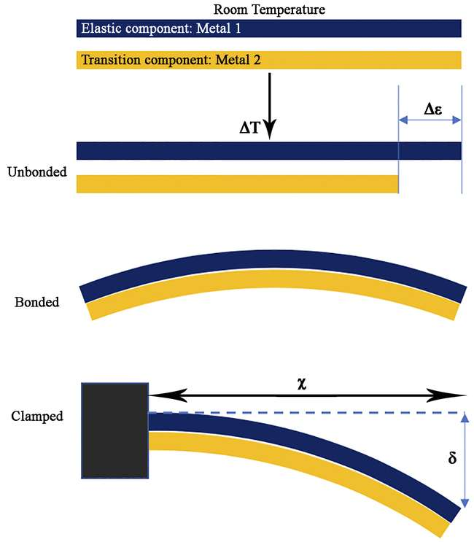

Figure 1 Operating principle of a bimetallic strip

*Experimental Project*: An example of architectural application can be seen in the ‘Bloom Experimental Pavilion’[1] in Los Angeles, designed by biologist-turned-architect Doris Kim Sung (Fig. 2). The façade is mainly made of 'intelligent' thermo-bimetal, a sheet metal that curves when heated (without controls, without energy). The modular elements consist of two aluminum sheets and can bend in seconds, autonomously, and without the presence of actuators. This behavior is possible because the two metal layers, although laminated together, when subjected to thermal stress can expand at different speeds, returning to their initial position when this stress fails. The installation responds to climatic temperature stress, reducing the heat island effect, thanks to the curling of metal elements (Orhon, 2016). It also makes use of complex digital software, as the surface is composed of approximately 14,000 laser-cut pieces. The façade consists of 414 panels stacked in the shape of a hyperbolic paraboloid and exploits the ability of materials to function as an envelope (Kanaani et al., 2016). The structure provides stability through an aluminum frame with interlocking connection.

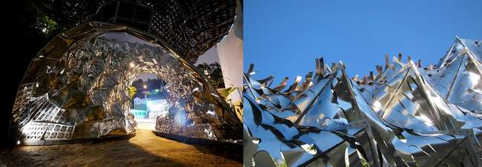

Figure 2 Bloom Experimental Pavilion

*Level of adaptation*: In this case study, the façade functions in the same way as human skin: thermo-bimetals use temperature to create a reactive, thermoregulatory system. When human skin is exposed to UV radiation, it thickens to protect itself. The thermo-bimetals that make up the adaptive façade mimic the way an organism behaves in its environmental context and, for this reason, can be associated with the behavior level.

*4.2. Shape Memory Alloy*

*Material*: Shape Memory Alloy (SMA) are materials that deform at a certain temperature but, once heated or cooled, back to their original form. Deformations up to about 10 per cent can be fully recovered (Yamauchi et al., 2011). Alloys that only show this effect when heated are called 'unidirectional shape memory'. SMAs also exhibit super-elasticity, which is a mechanical type of shape memory (Huang et al., 2010). At low temperatures, the material appears as *martensite* (Fig. 3) and deforms with a small application of force. At high temperatures, the material exists as *austenite*, which does not deform easily (Elahinia et al., 2014). is the most commonly used SMA in the reactive envelope that follows the non-diffusive phase transition protocol as an actuator due to its robust mechanical properties (Sun et al., 2012). NiTi alloys are the most commonly used due to their corrosion resistance, ductility, high recoverable deformation and biocompatibility (Duerig et al., 1999).

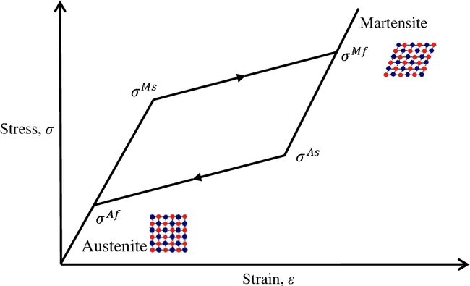

Figure 3 The phases of the transition: from the austenite to the martensite phase

*Experimental Project*: A prototype with this type of material is built by the Institute of Advanced Architecture of Catalonia. The study develops a passive kinetic motor with Nitinol alloy that can manage and respond to solar stress. It generates a ring displacement movement of an independently moving mechanism. The experimental prototype ‘Self-Adaptive Membrane’[2] (Fig. 4) consists of two vital components: nitinol kinetic joints and collapsible tessellation geometry, which work together as one integrated system. The self-adaptive membrane has 16 Nitinol springs positioned to form 4 cluster joints that mobilize the model (Fig. 5). The joints allow for uniform opening in both volume and surface. In the absence and presence of high temperatures, the alloy is able to contract and expand the system. When the internal thermal delta exceeds the allowable threshold, hot air is released through a perforated panel system.

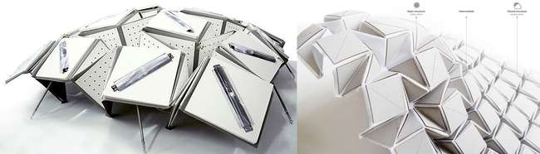

Figure 4 Self-Adaptive Membrane

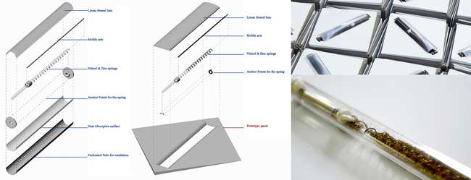

Figure 5 Nitinol joints and components

*Level of adaptation*: In this case study, nature's emulation comes from the world of plants, which can regulate the transpiration and cooling process using specialized plant organs called stomata. The kinetic joints in Nitinol can be likened to stomata and function as specialized leaf cells that can open or close, limiting heat storage on the surface. The variation in opening and closing and thus in the morphology of the self-adapting membrane is associated with the organism's level of adaptation.

*4.3. Shape Memory Polymers*

*Material*: Shape Memory Polymers (SMPs) are an emerging type of active polymers with dual-shape capabilities (Behl et al., 2007). So far, the most widely studied group of SMPs have been thermally induced SMPs, which are triggered by heat (Behl et al., 2010). These materials vary form by default from form A (initial processing step) to form B (programming) when subjected to a specific force (Fig. 6) (Behl et al., 2007; Odent et al., 2017). Through the starting processing step, the permanent form can be established above the 'switching temperature' TSW. An external mechanical force, which is applied to the material below TSW, is required to activate the subsequent programming of the temporary shape (Hager et al., 2015). At temperatures above TSW during use, the device reverts to its permanent form. The programmability and restoration cycle can be repeatable a number of times (Hager et al., 2015). Low-temperature phase deformations, which occur above critical stress, are fully recovered during solid-solid transformation at the high-temperature phase (Hu et al., 2012).

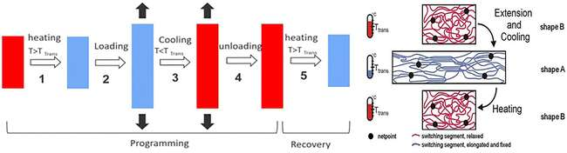

Figure 6 Shape-memory effect in polymers (Ttrans= Thermal transition related to switching phase)

*Experimental Project*: The project analyzed is the 'Breathing Skins'[3], which originated as Becker's degree thesis at the University of Stuttgart and is developed in Mandelbachtal, Germany, in 2015. Breathing Skins work by increasing or decreasing the size of openings spread across the surface to control of heat flow between inside and outside. These adjustable air channels (Fig. 7), as air muscles, can be closed pneumatically using the air pressure within the façade (Frighi, 2021). The transformation processes require a minimum supply of energy. The adaptive skin promotes solar and thermal control.

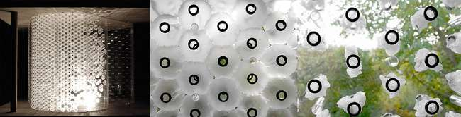

Figure 7 Adaptive behavior of air channels

*Level of adaptation*: The technology used to adapt the façade to environmental conditions is inspired by the behavior of human muscles. The level of adaptation emulated is the behavior level, as the 'pneumatic muscles' expand and close to control external conditions and allow light to penetrate the interior, also depending on the settings chosen by users. The operation of the actuator in SMP is based on the same principles as human muscles. Depending on the angle between the fibers, the actuator can extend and contract, and by changing the initial angle between the fibers, a variable stiffness is achieved at each point along the actuator's total stroke.

*4.4. Electro-Active Polymers*

*Material*: When an electrical stimulus passes by the laminate and generates a contraction of the elastomer, it stimulates the activation of the deformation behavior of electroactive polymers (Villegas et al., 2020). A typical dielectric electroactive polymer (DEAP) is made of a dielectric elastomer membrane located between two electrodes (Cao et al., 2020) (Fig. 8). Components made of these materials present two main characteristics: a dielectric film and electrodes for electrical stimulation (Benslimane et al., 2010). The degree of conformity of these electrodes determines the amount of dimensional variation allowed (Hodgins et al., 2015). For example, in actuator mode, an electrical potential difference has the ability to convert electrical energy into mechanical energy (Benslimane et al., 2010).

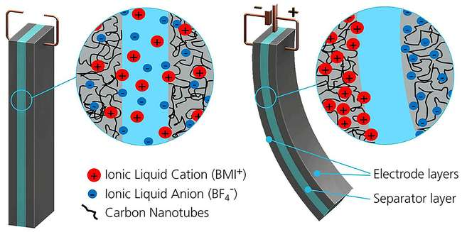

Figure 8 Deformation in EAP

*Experimental Project*: The prototype is the 'Homeostatic Façade Prototype'[4] in New York. It is a glass facade system that varies its geometry with respect to the change in temperature and light source. The technology uses artificial musculature to control the percentage of openings in a shading system to prevent solar heat gain. The EAP material is wrapped around a flexible core that can fold with the deformation of the actuator (Persiani, 2020). The type of electrode used is a 200 nm thick silver layer (Decker, 2016). The sensitive actuator moves when there is movement in the silver element. The increase in charge causes the elastomer to expand, bending the core and pulling the elastomer to one side. The result is the closure of the façade, regulating the temperature inside the building (Fig. 9).

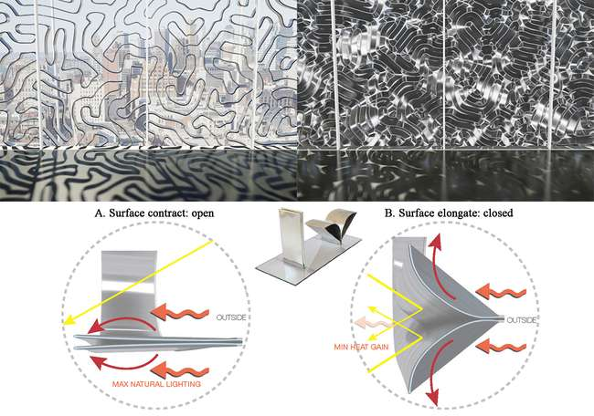

Figure 9 Façade behavior in response to temperature differences

*Level of adaptation*: EAPs work like artificial muscles. When a voltage is applied to the system (temperature difference), the electrostatic forces are able to deform the polymer (Bengisu et al., 2018). The transfer of muscle behavior to the self-regulating behavior of the facade is identified in the behavioral level of the biomimetic approach.

1. **Results and discussions**

The systematic study of the material characteristics of the case studies highlights the intrinsic and extrinsic capacities of a strategic and dynamic organization. The research explores the adaptive building envelope and systematizes the information on the use of innovative technologies.

The result is a summary sheet that relates the adaptive characteristics of materials to environmental stimuli (in this case reaction to temperature) with the adaptation levels of the biomimetic approach (Fig. 10). The sheet is a tool to direct material choices for future adaptive envelope components for better management, understood as mitigation and adaptation, of extreme climate change events. Furthermore, this repertoire supports the prototyping of adaptive building envelopes with a biomimetic matrix. All these systems show different ways of addressing the problem of adaptive response to variable micro-environmental changes. However, further testing is needed to massively develop and deploy these types of enclosure systems due to the high costs that limit their application.

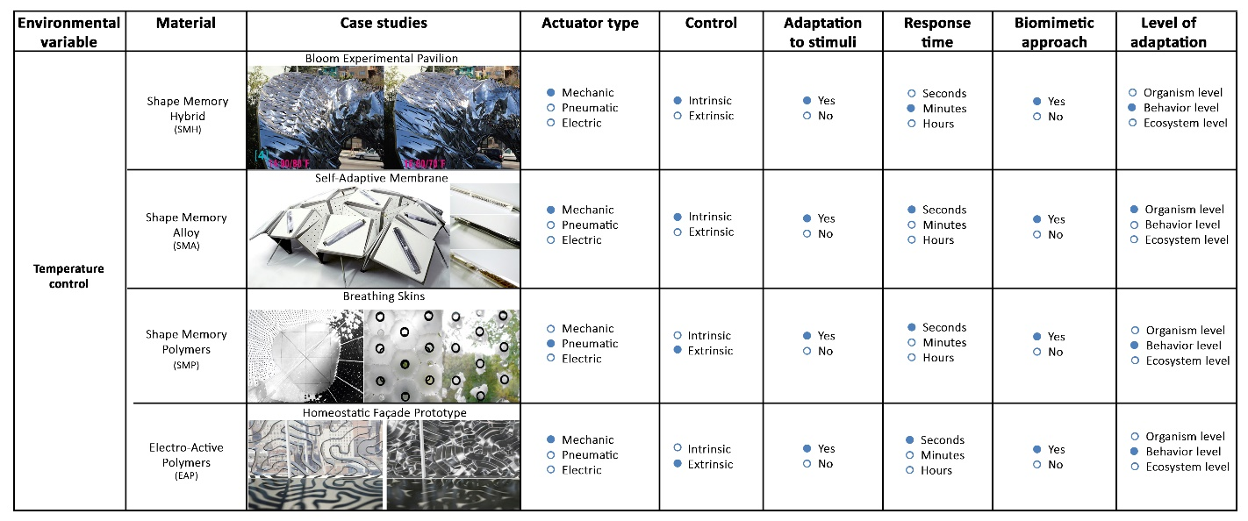

Figure 10 Adaptive strategies of smart materials for temperature control

This activity is necessary for knowledge acquisition about material innovation and experimentation and to select the most suitable material for the adaptive model for curtain walls in ongoing experimental research. Through the investigation of the experimental projects analyzed, emerges a substantial change in the conception of the link that exists from the built environment to nature. As in nature, where design develops from the small to the large scale, material design should develop in the same way as nature to meet specific building and environmental criteria, which serve as design goals. The projects considered here demonstrate and contribute to the application of adaptive materials in architecture, the result of the latest technological innovations, for a further renewed debate on the concepts of innovation and environmental sustainability. For these reasons, the responsible use of new biomimetic materials aims at sustainably preserving the built environment.

The innovative aspects of this study involve multiple scales: firstly, at the scale of materials, performance optimizations achievable through solutions inspired by nature are traced; at the scale of constructions, adaptive components such as biomimetic devices are identified to raise their performance response to varying user needs and environmental influences due to climate change (Antonini et al., 2021). The study activities cannot be considered comprehensive and complete due to the complexity of the subject matter, and new fields of innovation are still to be investigated.

However, the following application potentials are noted:

* *Technological and production impact*: an increase in the realization of products and innovative materials for climate change adaptation, aimed at market trends and efficient building envelopes;
* *Scientific impact*: the study aims to highlight how the design of adaptive building envelopes with a biomimetic matrix requires adequate scientific information in the era of environmental, ecological, digital, economic and social transition.

For this reason, emulating nature becomes a necessary and sufficient prerequisite for the design of the envelopes to maintain an optimal state of equilibrium in relation to specific environmental conditions.

1. **Conclusions**

The research objectives aim to respond to the environmental challenges of the scientific debate of recent decades. Designing buildings that are living and understood as 'environmental moderators' (Lopez et al., 2017) is the goal of changing the cultural and architectural paradigm. Many material innovations draw their inspiring principles from nature. The most fertile application scale seems to be the molecular or nanomaterial scale to realize advanced materials, elements, and components. The research theme is part of the new dynamic performance of the architectural envelope, through mechanical elements, typological, stratigraphic, material passivity, and biomimetic strategies. Incorporating these principles in the adaptive model to be applied to new or existing curtain walls becomes an essential activity for an architecture that intends to follow the laws governing life processes and cycles.

Future research developments are moving towards the definition and development of an adaptive model using one of the materials analyzed. In addition, it would be interesting to test the performance of the chosen material in the Thermal Chamber (size 7x9m) of the TCLab Section of the BFL - Building Future Lab - of the Mediterranea University of Reggio Calabria (Trombetta et al., 2015), built-in compliance with AAMA 501.5-07 "Test Method for Thermal Cycling of Exterior Walls" for the simulation of thermal shocks and solar radiation. The performance involves extreme thermal cycles as per standard: +88 C°/ -18 C° for 5h, at a constant internal temperature of 24 C°.

The activities and perspectives of applied research and experimentation outline concrete solutions on a theoretical and operational level, moving towards an increasingly controlled vision of the relationship between innovation and architectural design.

**Acknowledgements**

The contribution is the result of the authors' research activities.

**References**

Addington, M., & Schodek, D. (2012). *Smart materials and technologies in architecture*. Routledge.

Al-Obaidi, K. M., Ismail, M. A., Hussein, H., & Rahman, A. M. A. (2017). Biomimetic building skins: An adaptive approach. *Renewable and Sustainable Energy Reviews*, *79*, 1472-1491. DOI: 10.1016/j.rser.2017.05.028

Antonini, E., Boeri, A., & Giglio, F. (2021). Classification criteria and markers for biomimetic building envelope within circular economy principles: a critical review. *Architectural Engineering and Design Management*, 1-23. https://doi.org/10.1080/17452007.2021.1891858

Attia, S., Lioure, R., & Declaude, Q. (2020). Future trends and main concepts of adaptive facade systems. *Energy Science & Engineering,* 8(9), 3255-3272. DOI: 10.1002/ese3.725

Badarnah, L., & Kadri, U. (2015). A methodology for the generation of biomimetic design concepts. *Architectural Science Review*, *58*(2), 120-133. DOI: 10.1080/00038628.2014.922458

Badarnah, L. (2017). Form follows environment: Biomimetic approaches to building envelope design for environmental adaptation. *Buildings*, *7*(2), 40. DOI:10.3390/buildings7020040

Ball, P. (2001). Life's lessons in design. *Nature*, *409*(6818), 413-416. DOI: 10.1038/35053198

Behl, M., & Lendlein, A. (2007). Shape-memory polymers. *Materials today*, 10(4), 20-28. DOI: 10.1016/S1369-7021(10)70128-0

Behl, M., Razzaq, M. Y., & Lendlein, A. (2010). Multifunctional shape‐memory polymers. *Advanced materials*, *22*(31), 3388-3410. DOI: 10.1002/adma.200904447

Bengisu, M., & Ferrara, M. (2018). Materials that Move. In *Materials that Move*, 5-38. Springer, Cham. DOI: 10.1007/978-3-319-76889-2_2

Benslimane, M. Y., Kiil, H. E., & Tryson, M. J. (2010). Dielectric electro‐active polymer push actuators: performance and challenges. Polymer International, 59(3), 415-421. DOI: 10.1002/pi.2768

Benyus, J. M. (1997). *Biomimicry: innovation inspired by nature*. New York: Morrow.

Benyus, J. M. (2002). *Biomimicry. Innovation Inspired by Nature*. William Morrow & Co., New York.

Bogatyreva, O., A.-K. Pahl, and J. F. V. Vincent. 2002. “Enriching TRIZ with Biology.” *TRIZ future, 2002: Proceedings ETRIA world conference*, 301–308. Strasbourg.

Burton, B. (2012). Climate change and the building envelope. *Risk Management*, 59(2), 12-14.

Butler, J. R. A., Wise, R. M., Skewes, T. D., Bohensky, E. L., Peterson, N., Suadnya, W., ... & Rochester, W. (2015). Integrating top-down and bottom-up adaptation planning to build adaptive capacity: a structured learning approach. *Coastal Management*, *43*(4), 346-364. DOI: 10.1080/08920753.2015.1046802

Cao, C., Hill, T. L., & Conn, A. T. (2019). On the nonlinear dynamics of a circular dielectric elastomer oscillator. *Smart Materials and Structures,* 28(7), 075020. DOI: https://doi.org/10.1088/1361-665X/ab1cc8

Conato, F., & Frighi, V. (2018). Il ruolo dell'innovazione nella definizione di nuovi paradigmi formali in Architettura. *TECHNE: Journal of Technology for Architecture & Environment*, *16*, 105-112. DOI: 10.13128/Techne-22965

Cosola, O. D., Sánchez-Reséndiz, J. A., Olivieri, L., & Olivieri, F. (2021). Actions for adaptation and mitigation to climate change: Madrid case study. *Revista Facultad de Ingeniería Universidad de Antioquia*, (101), 84-99. DOI: https://doi.org/10.17533/udea.redin.20200795

Daveiga, J., & Ferreira, P. (2005). Smart and nano materials in architecture. *ACADIA2005 Conference: Smart Architecture, 58-67.* Online: http://papers.cumincad.org/data/works/att/acadia05_058.content.pdf

Decker, M. (2013). EMERGENT FUTURES: nanotechology and emergent materials in architecture. In *Conference of Tectonics of Teaching: Building Technology Educators Society (BTES)., Newport: Rhode Island*.

Duerig, T., Pelton, A., & Stöckel, D. J. M. S. (1999). An overview of nitinol medical applications. *Materials Science and Engineering: A*, *273*, 149-160.

Elahinia, M., Andani, M. T., & Haberland, C. (2014). Shape memory and superelastic alloys. *High Temperature Materials and Mechanisms*, *355*. ISBN 9781138071544

Elsamadisy, R., Sarhan, A. E., Farghaly, Y., & Mamdouh, A. (2019). Biomimicryas a design approach for adaptation. *Journal of Al-Azhar University Engineering Sector*, *14*(53), 1516-1533. DOI: 10.21608/AUEJ.2019.64210

European, C. (2019). Il Green Deal europeo. *Comunicazione della Commissione al Parlamento Europeo, al Consiglio, al Comitato Economico e Sociale Europeo e al Comitato delle regioni.* Bruxelles*,* COM (2019), 640 final. Online: https://eur-lex.europa.eu/resource.html?uri=cellar:b828d165-1c22-11ea-8c1f-01aa75ed71a1.0006.02/DOC_1&format=PDF – Accessed on 13 May 2022

Frighi, V. (2021). *Smart Architecture–A Sustainable Approach for Transparent Building Components Design*. Springer Nature. ISBN: 978-3-030-77606-0

Gaertner, M. Á., González-Alemán, J. J., Romera, R., Domínguez, M., Gil, V., Sánchez, E., ... & Nikulin, G. (2018). Simulation of medicanes over the Mediterranean Sea in a regional climate model ensemble: impact of ocean–atmosphere coupling and increased resolution. *Climate dynamics*, *51*(3), 1041-1057. DOI: 10.1007/s00382-016-3456-1

Grillo, E., & Sansotta, S. (2021). Experimentation of a new adaptive model for envelope systems. *Possible and preferable scenarios of a sustainable future: Towards 2030 and beyond*, Vol. 5, 166-177. DOI: doi.org/10.19229/978-88-5509-232-6/5102021

Hager, M. D., Bode, S., Weber, C., & Schubert, U. S. (2015). Shape memory polymers: Past, present and future developments. *Progress in Polymer Science*, *49*, 3-33. DOI: 10.1016/j.progpolymsci.2015.04.002

Hamburg, I. B. (2013). *Smart Material Houses. BIQ*. IBA Hamburg GmbH, Hamburg. Online: https://www.internationale-bauausstellung-hamburg.de/fileadmin/Slideshows_post2013/02_Wissen/01_Whitepaper/130716_White_Paper_BIQ_en.pdf – Accessed on 16 May 2022

Hill, R. W., Wyse, G. A., Anderson, M., & Anderson, M. (2004). *Animal physiology* (Vol. 2). Massachusetts: Sinauer associates.

Hodgins, M., Rizzello, G., Naso, D., York, A., & Seelecke, S. (2014). An electro-mechanically coupled model for the dynamic behavior of a dielectric electro-active polymer actuator. *Smart Materials and Structures*, *23*(10), 104006. DOI: 10.1088/0964-1726/23/10/104006

Huang, W. M., Ding, Z., Wang, C. C., Wei, J., Zhao, Y., & Purnawali, H. (2010). Shape memory materials. *Materials today*, *13*(7-8), 54-61. DOI: 10.1016/S1369-7021(10)70128-0

Hu, J., Zhu, Y., Huang, H., & Lu, J. (2012). Recent advances in shape–memory polymers: Structure, mechanism, functionality, modeling and applications. *Progress in polymer science*, *37*(12), 1720-1763. DOI: 10.1007/s10853-007-2176-7

IPCC (2021). *Climate Change 2021. The Physical Science Basis. Summer for Polycymakers. Working Group, I contribution to the Sixth Assessment Report of the Intergovernamental Panel on Climate Change*. Online: https://ipccitalia.cmcc.it/messaggi-chiave-ar6-wg1/ – Accessed on 25 April 2022

Kanaani, M., & Kopec, D. (2016). *The Routledge Companion for Architecture Design and Practice*. New York, NY: Routledge. ISBN 9781315775869

Konarzewska, B. (2017). Smart materials in architecture: useful tools with practical applications or fascinating inventions for experimental design?. In *IOP Conference Series: Materials Science and Engineering* (Vol. 245, No. 5, p. 052098). IOP Publishing. doi:10.1088/1757-899X/245/5/052098

Lionello, P., & Scarascia, L. (2020). The relation of climate extremes with global warming in the Mediterranean region and its north versus south contrast. *Regional Environmental Change*, *20*(1), 1-16. DOI: 10.1007/s10113-020-01610-z

Liu, C., Qin, H., & Mather, P. T. (2007). Review of progress in shape-memory polymers. *Journal of materials chemistry*, *17*(16), 1543-1558. DOI: 10.1039/B615954K

Loonen, R. C. G. M., Rico-Martinez, J. M., Favoino, F., Brzezicki, M., Ménézo, C., La Ferla, G., & Aelenei, L. (2015). Design for façade adaptability–Towards a unified and systematic characterization. In *Proc. 10th Energy Forum-Advanced Building Skins, Bern, Switzerland*, 1274-84

López, M., Rubio, R., Martín, S. & Croxford, B. (2017). How plants inspire façades. From plants to architecture – Biomimetic principles for the development of adaptive architectural envelopes”. In *Renewable and Sustainable Energy Reviews*, vol. 67, pp.692-703. DOI: 10.1016/j.rser.2016.09.018

Lucarelli, M. T. (2018). Verso una nuova centralità ecologica dell’ambiente costruito. *Eco Web Town*, Vol. II (18), 7-12. ISSN: 2039-2656. Online: http://www.ecowebtown.it/n_18/pdf/18_02.pdf

Lucarelli, M. T., Milardi, M., Mandaglio, M., & Musarella, C. C. (2020). Macro phenomena vs micro responses. Multiscale approaches in the dynamic relationship between envelope and context. *AGATHÓN| International Journal of Architecture, Art and Design*, *7*, 26-33. DOI: https://doi.org/10.19229/2464-9309/732020

Mandaglio, M. (2019). Chameleon Building. In *IOP Conference Series: Earth and Environmental Science*, vol. 296, No. 1, p. 012014. IOP Publishing. DOI: 10.1088/1755-1315/296/1/012014

Marmur, A. (2004). The lotus effect: superhydrophobicity and metastability. *Langmuir*, *20*(9), 3517-3519. DOI: https://doi.org/10.1021/la036369u

MedECC (2020). *Climate and Environmental Change in the Mediterranean Basin – Current Situation and Risks for the Future. First Mediterranean Assessment Report* (Cramer, W., Guiot, J., Marini, K. eds.) Union for the Mediterranean, Plan Bleu, UNEP/MAP, Marseille, France, 632pp. ISBN: 978-2-9577416-0-1 / DOI: 10.5281/zenodo.4768833 – Accessed on 10 April 2022

Milardi, M. (2006). Il concetto di metabolismo per la gestione dei flussi energetici e materiali dell'ambiente urbano. In: Lucarelli, M. T. (2006). *L'Ambiente dell'organismo città. Strumenti e sperimentazioni per una nuova qualità urbana*. Alinea Editrice, Firenze – Italia. ISBN: 88-6055-056-4

Milardi, M., & Mandaglio, M. (2020). Architettura e biomimesi: la natura come risorsa per il progetto. In Perriccioli, M., Rigillo, M., Russo Ermolli, S., & Tucci, F. (a cura di) *Design in the digital age. Technology Nature Culture* (2020), 346-349, Maggioli Editore. ISBN 978-88-916-4327-8

Odent, J., Raquez, J. M., Samuel, C., Barrau, S., Enotiadis, A., Dubois, P., & Giannelis, E. P. (2017). Shape-memory behavior of polylactide/silica ionic hybrids. *Macromolecules*, 50(7), 2896-2905. DOI: https://doi.org/10.1021/acs.macromol.7b00195

Odum, E.P. (1983). *Basic Ecology*. CBS College Publishing. New York. ISBN: 0030584140.

ONU (2015). Trasformare il nostro mondo: l’Agenda 2030 per lo Sviluppo Sostenibile. *Risoluzione adottata dall’Assemblea Generale il*, *25*. Online: https://asvis.it/public/asvis/files/traduzione_ITA_SDGs_&_Targets.pdf – Accessed on 29 April 2022

Orhon, A. V. (2016). Adaptive building shells. In *Developments in Science and Engineering*, 555-567. Chapter: 39. Publisher: St. Kliment Ohridski University Press. Editors: R. Efe, L. Matchavariani, A. Yaldır, L. Lévai. ISBN: 978-954-07-4137-6

Pawlyn, M. (2011). Biomimicry in Architecture. Riba Publishing, London.

Persiani, S. G. (2020). Design of Autoreaction, Case Studies. In *Design of Autoreaction*, 157-192. Springer, Singapore. DOI: 10.1007/978-981-15-6178-8_6

Pietroni, L., & Mascitti, J. (2006). Superfici biomimetiche. *MD Journal 1(2006)*, 66-77. ISBN: 978-88-940517-3-5.

Poneti, K. (2019). Il cambiamento climatico tra governance del clima e lotta per i diritti. *Jura Gentium: Rivista di filosofia del diritto internazionale e della politica globale*, *16*(1), 116-182. ISSN-e 1826-8269, Vol. 16, Nº. 1, 2019 *“La crisi dei paradigmi e il cambiamento climatico”.* Online: https://dialnet.unirioja.es/servlet/articulo?codigo=7010678 – Accessed on 11 May 2022

Romano, R., Aelenei, L., Aelenei, D., & Mazzucchelli, E. S. (2018). What is an adaptive façade? Analysis of Recent Terms and definitions from an international perspective. *Journal of Facade Design and Engineering*, *6*(3), 65-76. DOI:10.7480/jfde.2018.3.2478

Ritchie, H. (2020). Sector by sector: where do global greenhouse gas emissions come from? *Our world in data*. Online avaible at: https://ourworldindata.org/ghg-emissions-by-sector – Accessed on 3 May 2022

Sun, L., Huang, W. M., Ding, Z., Zhao, Y., Wang, C. C., Purnawali, H., & Tang, C. (2012). Stimulus-responsive shape memory materials: a review. *Materials & Design*, 33, 577-640. DOI: https://doi.org/10.1016/j.matdes.2011.04.065

Tsai, W. T., & Tsai, C. H. (2022). Interactive analysis of green building materials promotion with relevance to energy consumption and greenhouse gas emissions from Taiwan’s building sector. *Energy and Buildings*, 261, 111959. DOI: https://doi.org/10.1016/j.enbuild.2022.111959

Trombetta, C., & Milardi, M. (2015). BUILDING FUTURE Lab.: a great infrastructure for testing. *Energy procedia*, 78, 657-662. DOI: https://doi.org/10.1016/j.egypro.2015.11.053

Villegas, J. E., Gutierrez, J. C. R., & Colorado, H. A. (2020). Active materials for adaptive building envelopes: A review. *Journal of Materials and Environmental Science*, *11*, 988-1009. ISSN : 2028-2508

Vincent, J. F. (2006). The materials revolution. *Journal of Bionic Engineering*, *3*(4), 217-234. DOI: https://doi.org/10.1016/S1672-6529(07)60005-5

Volkmer Martins, B., Faccin, K., Espindula, E., & Balestrin, A. (2019). *Understanding innovation ecosystems: a biomimetic approach*. Revue Internationale d’Intelligence Economique- R2IE, 2019. HAL.-02863882, Online: https://hal.archives-ouvertes.fr/hal-02863882/document

UE Commission (2011/696). *RECOMENDACIÓN DE LA COMISIÓN de 18 de octubre de 2011 relativa a la definición de nanomaterial. (2011/696/UE).* Online: https://eur-lex.europa.eu/legal-content/ES/TXT/PDF/?uri=CELEX:32011H0696&from=PL – Accessed on 18 May 2022

Wang, T. X., Renata, C., Chen, H. M., & Huang, W. M. (2017). Elastic shape memory hybrids programmable at around body-temperature for comfort fitting. *Polymers*, 9(12), 674. DOI: 10.3390/polym9120674

WMO (2021). *Mediterranean gripped by extreme heat, with new reported temperature record.* WMO. Online: https://public.wmo.int/en/media/news/mediterranean-gripped-extreme-heat-new-reported-temperature-record – Accessed on 20 May 2022

Wolman, A. (1965). The metabolism of cities. *Scientific American*, *213*(3), 178-193. https://www.jstor.org/stable/24931120

Yamauchi, K., Ohkata, I., Tsuchiya, K., & Miyazaki, S. (Eds.). (2011). *Shape memory and superelastic alloys: Applications and technologies*. Elsevier. ISBN: 9780081017012

Zari, M. P., & Storey, J. B. (2007, September). An ecosystem based biomimetic theory for a regenerative built environment. In *Sustainable building conference* (Vol. 7). Lisbon, Portugal.

1. Online: https://www.dosu-arch.com/bloom
2. Online: http://materiability.com/self-adaptive-membrane/
3. Online: https://parametrichouse.com/breathing-skins/
4. Online: https://materialdistrict.com/article/homeostatic-facade-system/