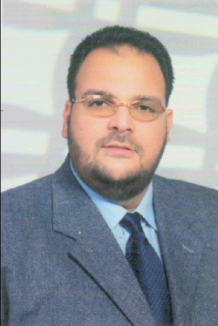
CURRICULUM VITAE

Name: | Mohamed Mahmoud Hosny Abdelrahim
Present Rank: | Associate Prof. (Surveying & Geodesy Chair Person)  Faculty of Engineering  Civil Engineering - Transportation Department  Alexandria University, Egypt

EDUCATION

- Ph.D, Department of Geodesy and Geomatics Engineering, University of New Brunswick (UNB), Canada.

- M.Sc.Eng., Faculty of Engineering- Civil Engineering Department-
Alexandria University (EGYPT).

- B.Sc.Eng., Faculty of Engineering- Civil Engineering Department-
Alexandria University (EGYPT).

University Career

Dec. 2005 to 2009 | Geomatics Engineering Technology- YANBU INDUSTRIAL COLLEGE (YIC)– Saudi Arabia  Geomatics Engineering Department (Chair)
Mar. 2009 to Present | Associate Prof. - Faculty of Engineering - Department of Civil Engineering, Alexandria University, (Egypt).
Aug. 2001 to Dec. 2005 | Ass. Prof. - Faculty of Engineering - Department of Civil Engineering, Alexandria University, (Egypt).
Sep. 1997 to July 2001 | Research Assistant & Ph.D Candidate, Department of Geodesy & Geomatics Engineering, University of New Brunswick, (Canada).
Oct. 1992 to Nov. 1994 | Instructor, Department of Civil Engineering, Alexandria University (EGYPT).

